**Glider Echoview Template** – Version 2 – March 28 2021

* Many things have been revised since the Mar 2020 version. This version adds swarms detection. It corrects use of pitch range, it was almost ignoring the pitch bitmap.
* It removes Dilation filter 7x7 as that was redundant.

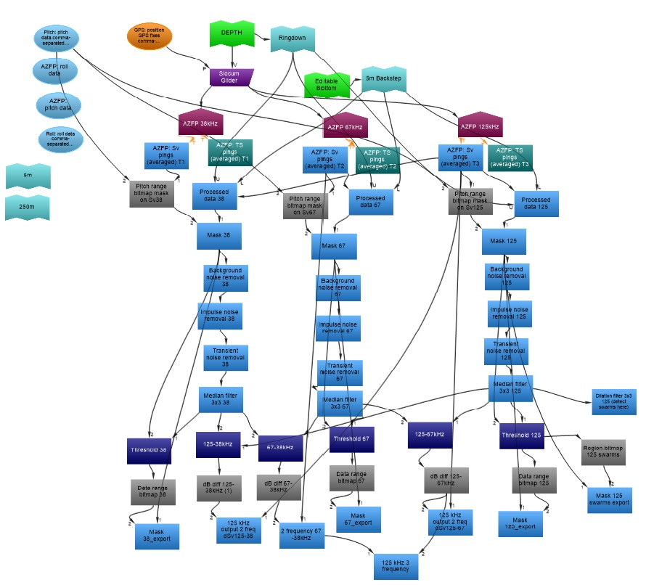

**Data needed before starting:**

AZFP data files (*.01A) – This is loaded in the AZFP tab in Filesets.

AZFP calibration file (*.ecs) - This is loaded in the AZFP tab in Filesets under Calibration.

GPS data files (*.gps.csv) – This is from glider telemetry data. Format will be a 4 column file with headers (GPS_date, GPS_time, Latitude, Longitude). Formatting examples are GPS Date (12/11/2018), GPS time (20:35:39), Latitude (-62.4823), Longitude (--61.1735). This file is loaded in the GPS tab in FIlesets.

Pitch data files (*.pitch.csv) – This is from glider data. Format is a three column file with headers (Pitch_date, Pitch_time, Pitch_angle). Formatting examples are Pitch_Date (12/11/2018), Pitch_time (20:35:39), Pitch_angle (-0.6). This is loaded in the Pitch tab in Filesets.

Roll data files (*.roll.csv) **currently not used so not necessary. There is minimal roll in the data so we haven’t used it. – This is from glider data. The format is three columns with headers (Roll_date, Roll_time, Roll_angle). Examples are Roll_Date (12/11/2018), Roll_time (20:35:39), Roll_angle (3.8999). This is loaded in the Roll tab in Filesets.

Depth data (*.evl) – This is from the glider data. This file is a little complicated. There are two header lines. Copy and paste ‘EVBD 3 8.0.73.30735’. This is an identifier for the Echoview line file saying it was created using Echoview 8.0 but this doesn’t matter. The second line is how many data rows are below. (For a 50,000 row data set the second line would be ‘50000’ without the quotes). The data (starting on row three) are four tab delineated columns but with no other headers. Columns are date (20181211) , time (2034270000) , depth (385.545), and a column of just 3’s (3). The number 3 means that the line is “good.” This file is loaded by going to “File” -> “Import…”, select the *.evl file and press OK. Select the “Extend/overwrite an existing line” option and select “DEPTH” then press Import. This will place the glider at the depth and time showing the acoustic data diving like a glider instead of horizontal like a ship.

**Variables in the dataflow**

**Lines –**

**Editable bottom** – This currently is a manually selected bottom. Automated bottom detection doesn’t work well with the breaks in data.

**5m Backstep** – This is an automatic 5m backstep from Editable bottom.

**Ringdown** – This is a 3m automatic offset from the surface line to account for a ringdown effect of the AZFP.

The platform is the “Slocum Glider”. Position source should be GPS: position GPS fixes comma-separated values. Platform type should be Position determined by GPS. The Heave source is DEPTH.

**Slocum Glider** has three transducers (AZFP 38 kHz, AZFP 67.5 kHz and AZFP 125 kHz).

This Template uses Sv (volume backscatter) but could be changed to TS (target strength) instead.

**AZFP Sv pings** (for each frequency) - Raw data from the AZFP

* Analysis – Exclude above : Ringdown Exclude below: 5m Backstep

**Processed data** (for each frequency) – Used to select just useable data (using exclude from Analysis)

* Operand: AZFP: Sv pings T2
* Analysis - Exclude above : Ringdown
  + Exclude below: 5m Backstep
  + check Apply bad data regions.
  + uncheck Include the volume of no-data samples

**Pitch range bitmap mask on Sv** (for each frequency) – Set the pitch range that makes glider data true

* Operand- 1. Sv pings (freq) Operand 2. Pitch: pitch data csv
* Motion Range Bitmap – Minimum in-range value(degrees): -30
  + Maximum in-range value(degrees): -10

**Mask** (freq) - This excludes the pitch range data so you will only see good pitch data

* Operand 1: Processed data Operand 2: Pitch range bitmap mask on Sv
* - Mask- Set masked data values to: No data

**Background noise removal** (freq) - Set this so that the “TVG rainbow effect” is removed from the data. This could change for each glider, deployment, and frequency.

* Operand 1: Mask (freq)
* Background Noise Removal –
  + Horizontal extent(pings): 20
  + Vertical units: Samples
  + Vertical extent (samples): 5
  + Vertical overlap (%): 0
  + Maximum noise (dB): -129 (125 kHz -118)
  + Minimum SNR: 10 (125 kHz 12)

**Impulse noise removal** (freq) - This identifies and adjusts sample values that are significantly higher than those of surrounding samples at the depth. Impulse noises are those such as interference from other sonars showing up as short ‘flecks.’ Care is required to prevent it from adjusting good data. This could change for each glider, deployment, and frequency.

* Operand 1: Background noise removal (freq)
* Impulse Noise Removal-
  + Exclude above: Ringdown
  + Exclude below: 5m Backstep
  + Exclude below threshold (dB at 1m): -145 (67 and 125 kHz -170)
  + Vertical window units: Samples
  + Vertical window size (samples): 5 (125 kHz 3)
  + Horizontal size (pings): 5 (125 kHz 7)
  + Threshold (dB): 10
  + Noise sample replacement value: No data

**~~Transient noise removal~~** ~~(freq) – This is similar to Impulse noise removal but you see long ‘spikes.’ Care is required to prevent it from adjusting good data. This could change for each glider, deployment, and frequency. You may be able to remove this if your data is good.~~

* ~~Operand 1: Impulse noise removal (freq)~~
* ~~Transient Noise Removal~~
  + ~~Exclude above: Ringdown~~
  + ~~Exclude below: 5m Backstep~~
  + ~~Exclude below threshold (dB at 1m): -170~~
  + ~~Vertical window units: Samples~~
  + ~~Vertical window size (samples): 3 (125 kHz 2)~~
  + ~~Horizontal size (pings): 7~~
  + ~~Vertical size (samples): 9 (125 kHz 11)~~
  + ~~Calculations per sample: 63 (125 kHz 77)~~
  + ~~Percentile: 50~~
  + ~~Threshold (dB): 9 (67 kHz 10) (125 kHz 7)~~
  + ~~Noise sample replacement value: No data~~

**Median filter 3x3** (freq) – This applies a 3x3 median filter.

* Operand 1: Transient nose removal (freq)

~~Dilation filter 7x7 (freq) Removed 2/1/21~~

* ~~Operand 1: Median filter 3x3 (freq)~~

**Threshold** (freq) – This compares the datapoint values and sets the maximum value as Mask (freq) if the datapoint values in Median 3x3 are higher.

* Operand 1: Median filter 3x3 (freq) Operand 2: Mask (freq)
* Threshold- Maximum threshold
  + Set thresholded values to: Datapoint value from operand 2

**Data range bitmap** (freq) – I’m using this as a pass through. That is why the values are so high. This could be used to make sure data aren’t too high.

* Operand 1: Threshold (freq)
* Data range bitmap
  + Minimum in-range data value: -150
  + Maximum in-range data value: 100

**Mask (freq)_exp**

Operand 1: Mask (freq) Operand 2: Data range bitmap (freq)

* Mask- no data
* Analysis
  + Exclude above: Ringdown
  + Exclude below: Either 5m Backstep or 250m (depending on the depth you want to integrate over).
* Grid
  + GPS distance (m): 1
  + Water surface (depth of zero): 1

**Dilation filter 3x3 125 (detect swarms here)**

Operand 1: Median filter 2x2 125

Detect schools here if you plan to use schools. Go to “Echogram” -> “Detect Schools”

Check Delete existing 2D regions with this class first

Assign Class: Krill School

Click “Properties” to set your school detection parameters

|  |  |  |  |  |  |  |  |
| --- | --- | --- | --- | --- | --- | --- | --- |
| **Study** | **Min total school length (m)** | **Threshold**  **(dB)** | **Min total school height (m)** | **Min candidate length (m)** | **Min candidate height (m)** | **Max vertical linking distance (m)** | **Max horizontal linking distance (m)** |
| Reiss et al 2021 | 7.5 | -75 | 2 | 1.5 | 2 | 2 | 3 |
| Guihen et al 2014 | 15 | -70 | 2 | 1.5 | 2 | 2 | 3 |

**Region bitmap 125 swarms**

This selects only the regions identified as “Krill School” and everything else is empty water

Operand 1: Threshold 125

Region type: Analysis

Region class: Krill School

**Mask 125 swarms export**

Operand 1: Mask 125

Operand 2: Region bitmap 125 swarms

References:

Guihen. D., Fielding, S., Murphy, E. J., Heywood, K. J., Griffiths, G. (2014). An assessment of the use of ocean gliders to undertake acoustic measurements of zooplankton: The 860 distribution and density of Antarctic krill (*Euphausia superba*) in the Weddell Sea, Limnol. 861 Oceanogr. Methods. 12, 373–389.

Reiss, C.S., Cossio, A.M., Walsh, J.G., Cutter, G., Watters, G.M. (2021) Glider-based estimates of meso-zooplankton biomass density: a fisheries case study on Antarctic krill (Euphausia superba) around the northern Antarctic Peninsula. Frontiers in Marine Science. doi: 10.3389/fmars.2021.604043